

**Salesforce Einstein Analytics Training Curriculum**

**STRUCTURE**

**www.cromacampus.com | helpdesk@cromacampus.com | +91-120-4155255**

**Salesforce Einstein Analytics Training Curriculum**

*“Start your Analytics journey! Set up Einstein Analytics, turn on features, and bring data in. Lay the foundation for effective analysis.”*

**Course Objectives:**

* Learn all about Salesforce Einstein Analytics platform
* Prepare for Salesforce Einstein Analytics Certification Exam
* Get placement assistance to get placed in top MNCs
* Learn about Data Integration concepts in Einstein Analytics
* Learn about datasets, data recipes, dashboards, dataflows, and more.

**Course Description:**

Company data lives in different locations, such as Salesforce, ERPs, data warehouses, and log files. When viewed together, all this data can be a gold mine, changing the way the one sees his business and improving the customers’ entire experience. Einstein Analytics solves the challenge of combining all this information to answer key questions of business users.

Einstein Analytics is secure, trusted, scalable, and, of course, mobile! It enables everyone in the org to get immediate access to powerful data insights through its intuitive point-and-click visual interface. Whether you’re on a desktop browser or a mobile device, you can get the answers you need from your data in order to run your business.

The technology powering Einstein Analytics is a game changer, allowing to bring self-service business intelligence to IT teams. No need to wait for IT to wrangle data and create complex queries. No schemas need to be designed. No installation required. Just get in! Get dirty! Get answers now with Einstein Analytics!

Here is a quick understanding of the Platform how it works actually and the same concepts you are doing to learn in training program too.

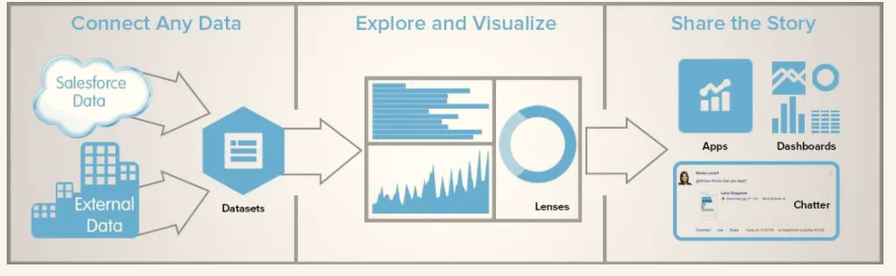

On the completion of the course, you will learn Salesforce Einstein Analytics basics, how to bring in your data from multiple data sources, how to explore and visualize data using different tools, and how to deploy the apps and other meaningful content to other platforms or share the story with the world!

**Course Content**

**Chapter 1: Introduction**

* Overview
* Concepts and Basic terminologies
* Benefits of Salesforce Einstein Analytics
* Einstein Analytics Components
  + Apps
  + Dashboard
  + Lens
  + Dataflow
* Sign up for a special Einstein Analytics Developer Edition org
* Setting up Platform
  + Basic Analytics Platform Setup
  + Advanced Analytics Platform Setup
  + Complete Setting up the Analytics Platform
* Define User types
* Define permission sets
* Define Salesforce Licenses
* Einstein Analytics Requirements
* Einstein Analytics Limits

**Chapter 2: Getting Started with Salesforce Einstein Analytics**

* Set Up Access & Security
* Sharing Mechanism
* Mass sharing
* Row level access and security predicates
* Grant Access and Permissions to Users
* Apply Security & Sharing Inheritance
* Analytics Security Implementation Guide
* Enable Einstein Analytics Features
* Control Access and Secure Data
* Setup Analytics Apps

**Chapter 3: Go mobile with Salesforce Einstein Analytics**

* Analytics Mobile Features
* Download the Analytics Mobile App
* Learn How to Use Analytics for iOS
* Learn How to Use Analytics for Android
* Set Up and Manage Analytics on Mobile
* Limitations of Analytics on iPhone and iPad
* Limitations of Analytics on Android Devices

**Chapter 4: Dataflows, Datasets, and Data Recipes**

* About Dataflows
  + Understanding Dataflows
  + Monitor Dataflows
  + Schedule Dataflows
  + Run A Dataflow
  + Run Manually
  + Run Automatically
  + Set Data flow notifications
* About Datasets
  + Columns and Rows in Datasets
  + Column Types in Datasets
  + Denormalized Data
  + Dataset Security
* Data Recipe
  + Understanding Data recipes
  + Scheduling Recipes
  + Exporting data from Einstein

**Chapter 5: Bring in Your Data**

* Getting started with Data Integration
* Ways to get data from data sources into datasets
* Plan for your data integration project
* Considerations Before Integrating Data into Datasets
  + Handle Numeric Values
  + Handle Date Values
  + Handle Text Values
  + Handle Missing Values
  + Dataset Capacity and Limits
* Prepare and Load Data into Datasets with Recipes and Dataflows
  + Connect and Sync Your Data to Einstein Analytics
  + Design Datasets from Synced Data and Other Datasets with Recipes and Dataflows
  + Run Data Sync, Recipes, and Dataflows to Create and Refresh Datasets
* Other Ways to Create Datasets
* Manage Datasets

**Chapter 6: Explore & Visualize Data in Einstein Analytics**

* Explore and Visualize Your Data in Einstein Analytics
* Learn to Use Explorer
* Explore Data with Tables
* Visualize Data with Charts
* Clone a Lens
* Save a Visualization
* Share a Visualization
* Explore Data Directly in Snowflake (Beta)

**Chapter 7: Knowing the Dashboards**

* Introduction to Dashboards
* Sales Dashboard
  + Create a dashboard for Sales
  + Understand Step and Static step
  + Bindings in Einstein
* Service Dashboards
  + Create a Service Dashboard
  + Understanding filters
  + Broadcast faceting
  + Custom Actions in Einstein
* Embedding Dashboards
  + Overview and importance
  + Embedding with Classic
  + Sharing with communities

**Chapter 8: Build Einstein Analytics Dashboards**

* Create an Analytics Dashboard with a Template
* Create Dashboard Pages
* Add Widgets to the Dashboard
* Manage Queries for Widgets
* Make the Dashboard Widgets Interactive
* Set Initial Selections and Global Filters in the Dashboard
* Generate Unique Analytics Dashboard Layouts for Different Devices
* Optimize Dashboard Performance
* Keyboard Shortcuts for Building Analytics Dashboards and Lenses
* Restore a Previous Version of a Dashboard
* Collaborate on a New Dashboard Version Behind the Scenes (Pilot)

**Chapter 9: Embed and Customize Analytics**

* Embed Dashboards Everywhere
* Add Actions to Analytics Lenses and Dashboards
* Integrate Analytics into Salesforce with an Analytics Tab
* Customize Onboarding with In-Dashboard Instructional Content
* Customize Analytics Dashboards using JSON
* Format Measures and Display Elements with Analytics Extended Metadata (XMD)

**Chapter 10: Create and Share Einstein Analytics Apps**

* App-Level Sharing
* Create an App
  + Set Up Navigation Through Your App
  + Share an App
  + Delete an App
* Analytics Migration, Packaging, and Distribution
  + Migrate Analytics Assets with Change Sets
  + Tips for Migrating Analytics Assets with an Ant Script
  + Package Analytics Assets in Managed Packages
  + Distribute Analytics Assets Through AppExchange
  + Use the Metadata API for Analytics Assets and User XMD
* Deploy Einstein Analytics Prebuilt Apps
* Develop with Analytics
  + Einstein Analytics Development Tools
  + Distribute Your Analytics Apps with Analytics Templates
  + Analytics Migration, Packaging, and Distribution
  + The Analytics SDK
  + The Analytics Dashboard Component
  + The Analytics REST API
  + Salesforce Analytics Query Language (SAQL)

**Chapter 12: Einstein Discovery**

* Set Up Einstein Discovery
* Get Started Using Einstein Discovery
* Define Your Use Case
* Prepare Data for Analysis
* Analyze Your Data and Investigate Insights
* Predict Outcomes and Take Actions

**Chapter 13: Placement Guide**

* Tips to clear an Interview
* Common Interview questions and answers
* Salesforce Einstein Analytics Interview Questions and Answers
* Resume Building Guide
* Attempt for Salesforce Einstein Analytics Global Certification Exam
* Start applying for Jobs